

**COLLEGE OF COMPUTING AND INFORMATION SCIENCES**

**DEPARTMENT OF NETWORKS**

**BACHELOR OF SCIENCE IN SOFTWARE ENGINEERING (YEAR 2) RECESS TERM 2 (BSE 2301)**

**SOFTWARE DESIGN DOCUMENT FOR:**

**GRAMMAR AND ONLINE PRODUCT REVIEWS**

**GROUP 8**

|  |  |  |
| --- | --- | --- |
| Name | Student Number | Registration number |
| Kimwero Dickson | 216000635 | 16/U/441 |
| Lumala David | 216003711 | 16/U/6679/eve |

Software Design Document

For

GRAMMAR AND ONLINE PRODUCT REVIEW ANALYSIS PROJECT

Version 1.0

Prepared by Kimwero Dickson and Lumala David

GROUP 8

July 10, 2018

**Table of contents**

**Table of contents** 2

1 Introduction. 4

1.1 Purpose. 4

1.2 Scope 4

1.2.1 Goal. 4

1.2.2 Objective. 4

1.3 Definitions, Acronyms and Abbreviations. 5

1.4 Overview. 5

1.4.1 System overview. 5

1.4.2 System architecture. 5

1.4.3 Component description. 5

1.4.4 Human interface design. 6

2 System overview 6

3 SYSTEM ARCHITECTURE 7

3.1 Architectural Design. 7

3.2 design rationale 8

3.3 decomposition description. 8

4 Component design 9

4.1.1 System features 9

5 Human interface design 10

5.1 overview of the user interface 10

5.2 USER INTERFACE SCREEN SHOTS 11

5.3 USER INTERFACE ACTIONS AND OBJECTS 13

6 REQUIREMENTS MATRIX 13

7 Reference 14

**Tale of figures**

Figure 1: Context diagram of the System architecture. 6

Figure 2: System architecture 7

Figure 3: Data flow diagram 9

Figure 4: Import dataset interface 11

Figure 5: Punctuation analysis interface 11

Figure 6: Punctuation vs Review rating interface 12

Figure 7: Star ratings interface 12

# Introduction.

This document will describe all details about the architecture and design of the Grammar and online product reviews system. This introduction part contains the purpose of this document and its scope.

## Purpose.

The document will elaborate all the functional operations, assumptions made and the flow of data in the system. The document will also show the User Interface design and how the user will interact with it to effectively and optimally use the system.

The intended audience for this document are the marketing staff for online products, product reviewers, product customers, product manufacturers, researchers and many online users.

## Scope

The Grammar and online product reviews system is a data analysis system that analyzes reviews from different products provided by Datafiniti’s Product Database. The dataset to be analyzed includes the text and title of the review, the name and manufacturer of the product, reviewer metadata and more.

Users of the system will be able to get analysis and insights on how the number of spelling errors, punctuation and review length for product reviews differ by rating.

### Goal.

To analyze product reviews and show how writing quality impacts positive and negative online product reviews.

### Objective.

1. Analyzing how the number of spelling errors differ by rating
2. Showing frequency of words with spelling errors and review length differ by rating
3. Showing the number of reviews that don’t end with punctuations and proportion of reviews with spelling errors.
4. Analyzing the distribution of star ratings across products and how long a typical review is.
5. To visualize all insights from the analysis made by the system for easy interpretation by the user

## Definitions, Acronyms and Abbreviations.

##### Below are the different Abbreviations and their meanings used in SDD tabulated

|  |  |
| --- | --- |
| **Abbreviation** | **Meaning** |
| SDD | System Design Document |
| IEEE | Institute of Electrical and Electronic Engineers. |
| CPU | Central Processing Unit. |
| RAM | Random access memory |

## Overview.

**This section contains the description of the system overview, its architecture and component description.**

### System overview.

**This part of the SDD contains the operations, functions and capabilities of the system to be developed and an understanding of how the users interact with the system to achieve the above-mentioned goal and objectives**

### System architecture.

**This shows the type of architecture design considered in the designing of the software product and the modular program structure with a description of how the different functions and modules relate to optimally use the system.**

**The main purpose is how the individual parts will work together and how the user interacts with them for quality analysis. It also describes the design rationale for the architecture.**

### Component description.

**This part provides short steps for each function and component of the system in a pseudo code step like format.**

### Human interface design.

**This explains how the user interacts with the system by showing the different user interface screen shots and describe each user interface actions and result of that action.**

# System overview

The Grammar and online product reviews system is for analyzing the data set uploaded by the user that contains a list of over 71,045 reviews from 1000 different products provided by Datafiniti’s Product Database. The system will analyze the dataset showing how grammar and punctuations of product reviews differ by rating. The system will then visualize all the insights gotten from the analysis.

Illustration of the overview of the system using a context diagram below



Figure 1: Context diagram of the System architecture.

# SYSTEM ARCHITECTURE

## Architectural Design.



Figure 2: System architecture

**SYSTEM ARCHITECTURE DESCRIPTION**

Below are the different components of the system architecture

**Users**

All the intended users of the system such as the marketing staff, product reviewers, and product manufacturers.

**Computer**

The computer system will be capable of hosting and running the system as well as displaying the user interface with at least a 2.5GHz CPU speed and 2GB RAM since the dataset are huge for the system to analyze. The Datasets can be on the same computer or on external devices connected to the computer. The system users will interact with the system through the user interface designed for ease of use.

**Data Store**

Since there is no need for a database, the dataset to be uploaded will be considered as the data stores.

## design rationale

The architecture was chosen because;

* The architecture doesn’t require any other software except the browser
* Direct communication between data and the system
* Database management is not necessary since we only use datasets
* Internet connection is not necessary

## decomposition description.

The context diagram is further broken down to different processes in the diagram below.

IMPORT DATASET process

This process involves the user importing the dataset to work with on the analysis

CHECK GRAMMAR process

This process is a system’s functionality for checking correctness of grammar for the product reviews after the user has imported the dataset.

CHECK PUNCTUATION process

This is also a system’s functionality for checking the punctuations for the product reviews.

VISUALIZE INSIGHTS

This process is responsible for graphically representing insights got from the above mentioned processes by displaying graphs.

**THE LEVEL 1 DATA FLOW DIAGRAM**



Figure 3: Data flow diagram

# Component design

### System features

**Import Dataset**

Steps

* Click on the Import Dataset tab
* Windows file explorer opens
* Select compatible csv dataset
* Click on open button to confirm file upload

**Check Punctuation**

Steps

* Click on Punctuation analysis tab
* Select analysis method
* Display analysis insights

**Check Grammar**

Steps

* Click on Grammar analysis tab
* Select analysis method
* Display analysis insights

**Get help**

Steps

* Click on the help tab
* Display the help information

# Human interface design

## overview of the user interface

This section has screen shots of the user interface design of the software product.

## USER INTERFACE SCREEN SHOTS

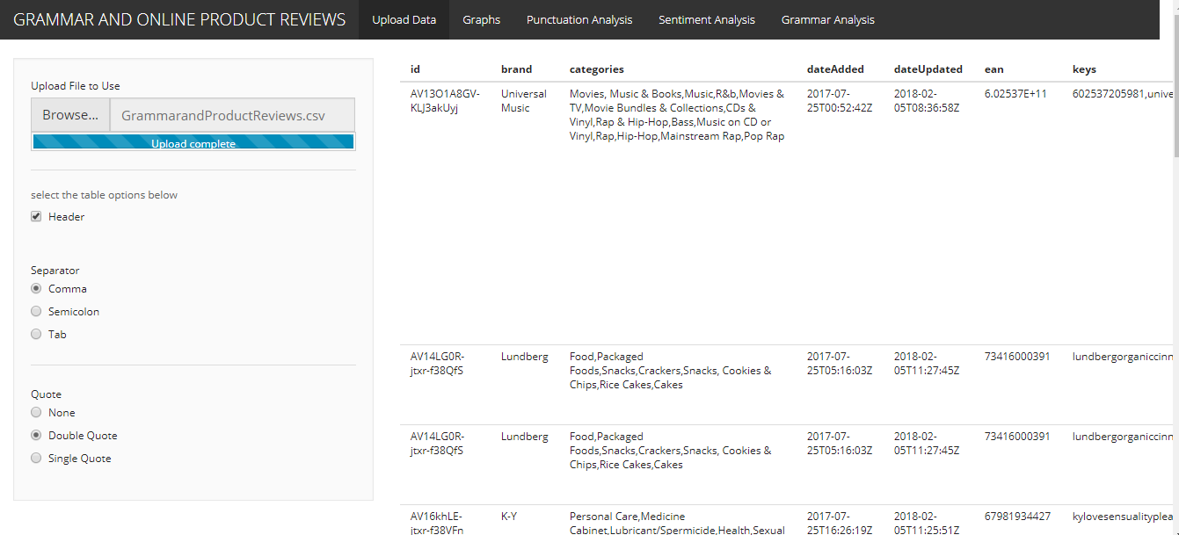

Figure 4: Import dataset interface

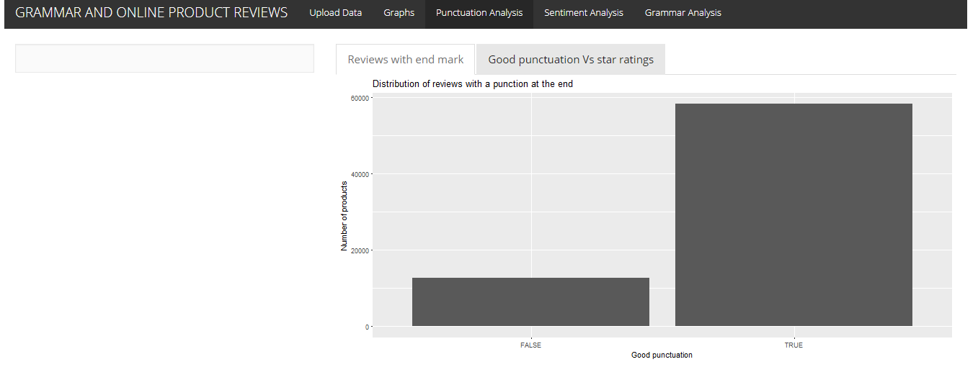

Figure 5: Punctuation analysis interface

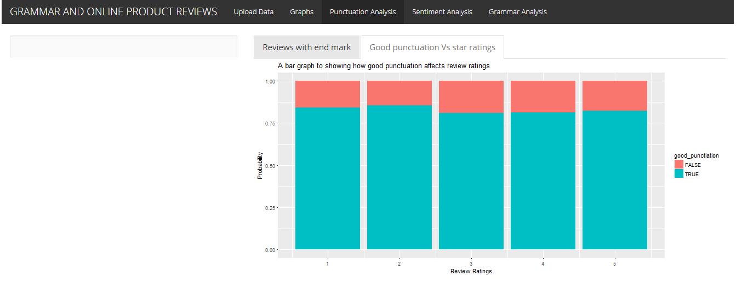

Figure 6: Punctuation vs Review rating interface

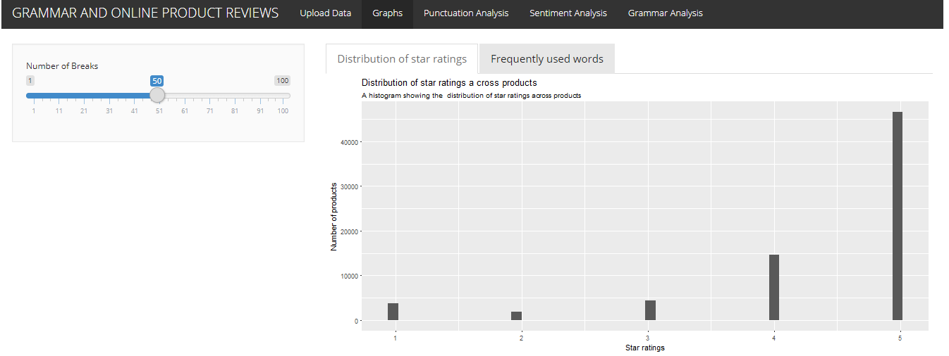

Figure 7: Star ratings interface

## USER INTERFACE ACTIONS AND OBJECTS

Figure 4

Figure 4 is a user interface that permits the user to import datasets into the system. The data fields in the dataset is then displayed.

Figure 5

This figure shows a graph for the distribution of reviews with punctuations at the end under punctuation analysis tab.

Figure 6

This screen shot displays a graph of how good punctuation verses star ratings which is also under punctuation analysis tab.

Figure 7

This screen shot displays a histogram graph of the distribution star ratings across products

# REQUIREMENTS MATRIX

**Requirements table**

|  |  |
| --- | --- |
| **Functional Requirement** | **Reference Section in SRS** |
| External Interface Requirements | 3 |
| System features | 4 |
| Other non-functional requirements | 5 |

# Reference

[1] Datafiniti’s Product Database:

<https://datafiniti.co/products/product-data/>

[2] IEEE Software Engineering Standards Committee, “IEEE Std 830-1998, IEEE Recommended Practice for Software Requirements Specifications”, October 20, 1998.

[3] Davis M A, “Just Enough Requirements Management: Where Software Development Meets Marketing”, New York, Dorset House Publishing, 2005.

[4] [Gary_B._Shelly, _Harry_J._Rosenblatt] _Systems_Analysis (BookFi.org)